IAM – Tasks

- Create one IAM user and assign EC2 and S3 full access roles.
Using AWS Console
Go to IAM → Users → Create User
Enter username: shahbaz
Click Next
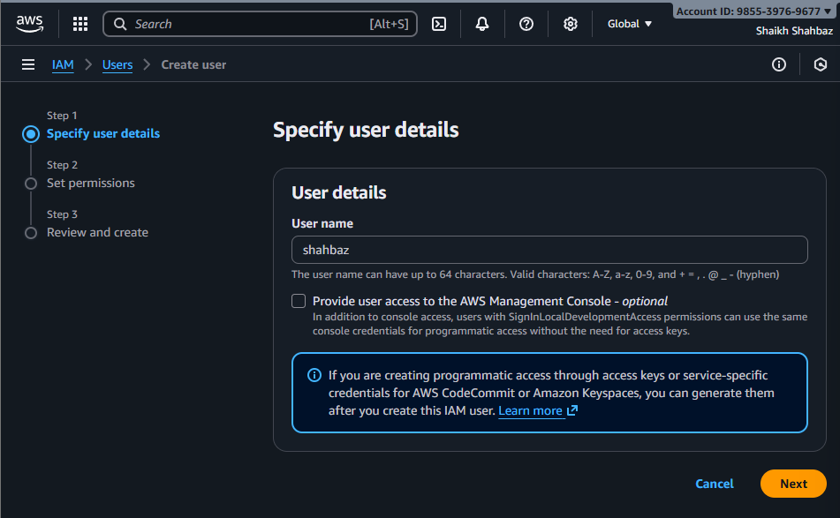
Under Permissions → Attach Policies Directly
Add:
  - AmazonEC2FullAccess
  - AmazonS3FullAccess
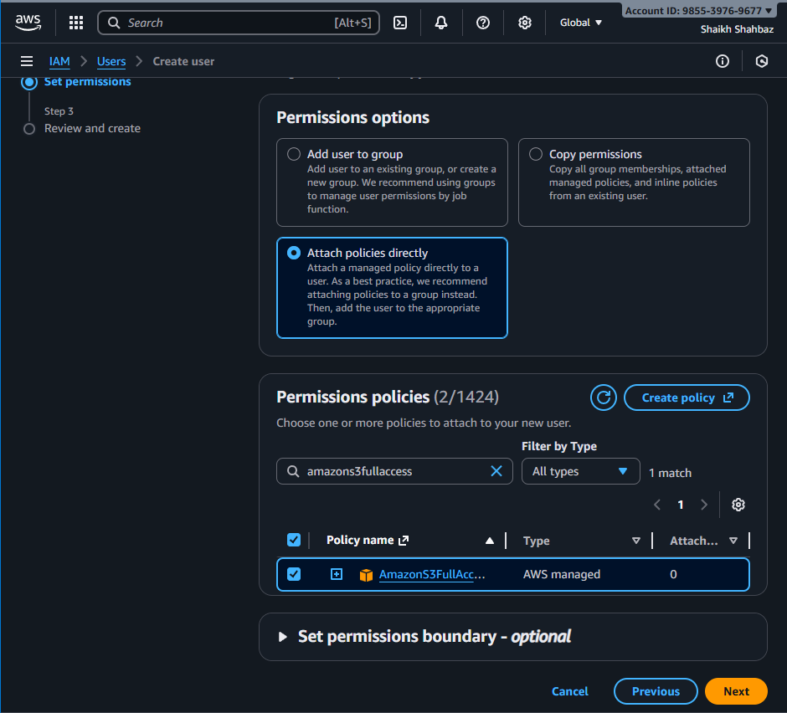
Create user.
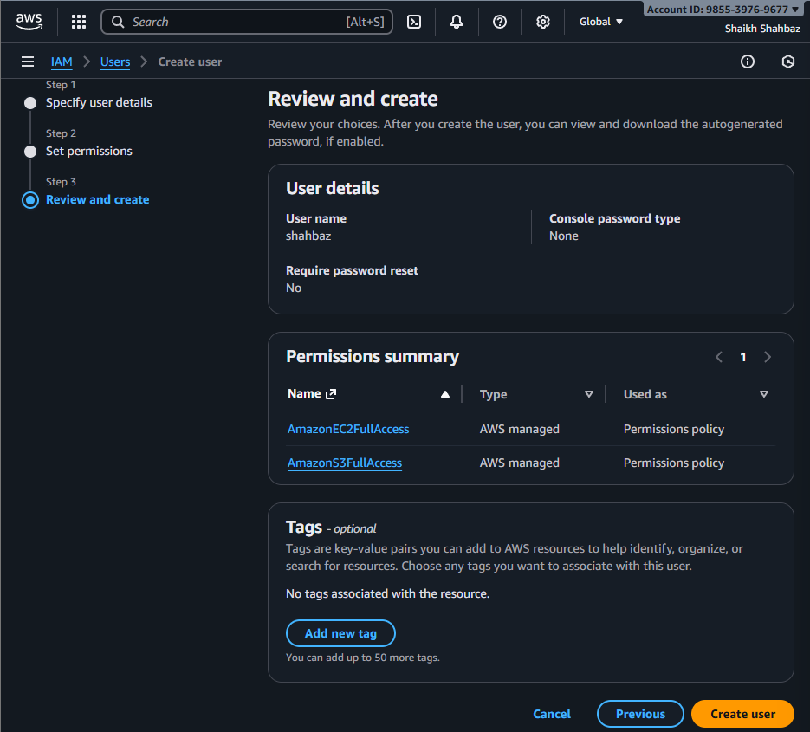
We can see that a user named <shahbaz> is created
With permissions : ec2 and s3 full access roles

- Create one group in IAM and assign read access for EC2.
Go to IAM User Groups Create Group
Name : ec2-readonly-group
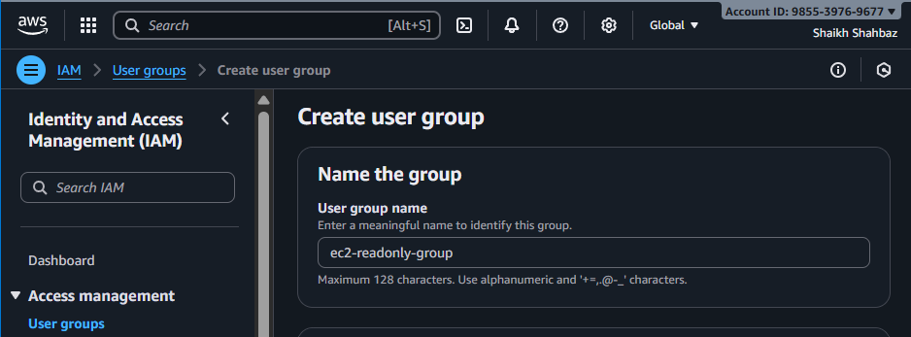
Attach Policy : AmazonEC2ReadOnlyAccess
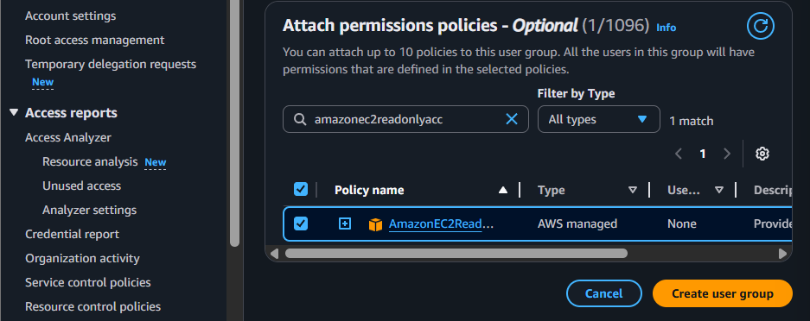
Create Group
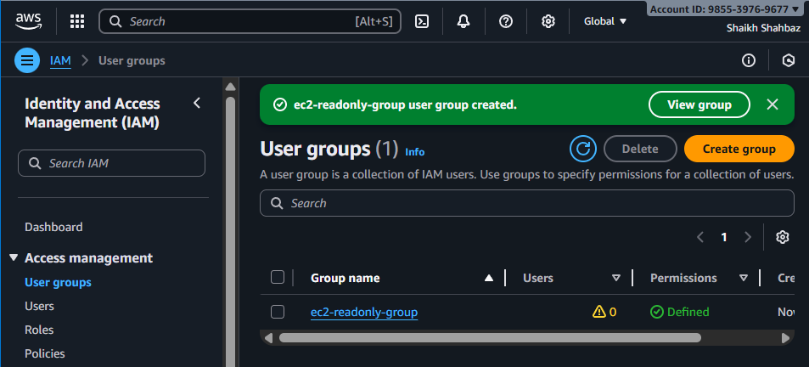

- Create a new user named "Devops" and add to the group created in task 2.
IAM Users Create User
Name : Devops
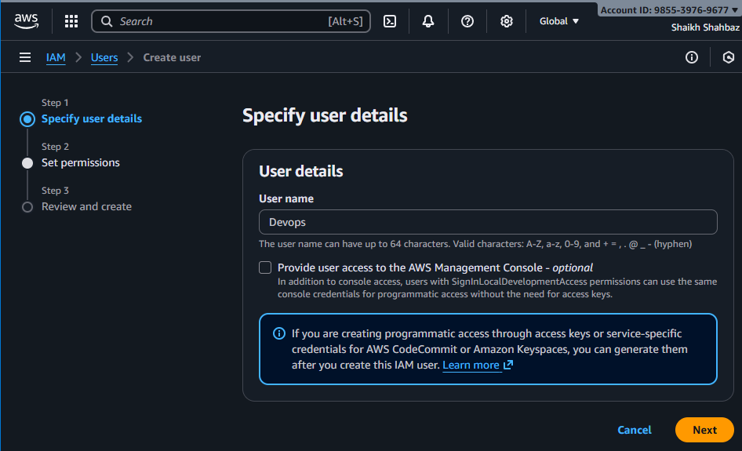
Next
Add user to group : ec2-readonly-group
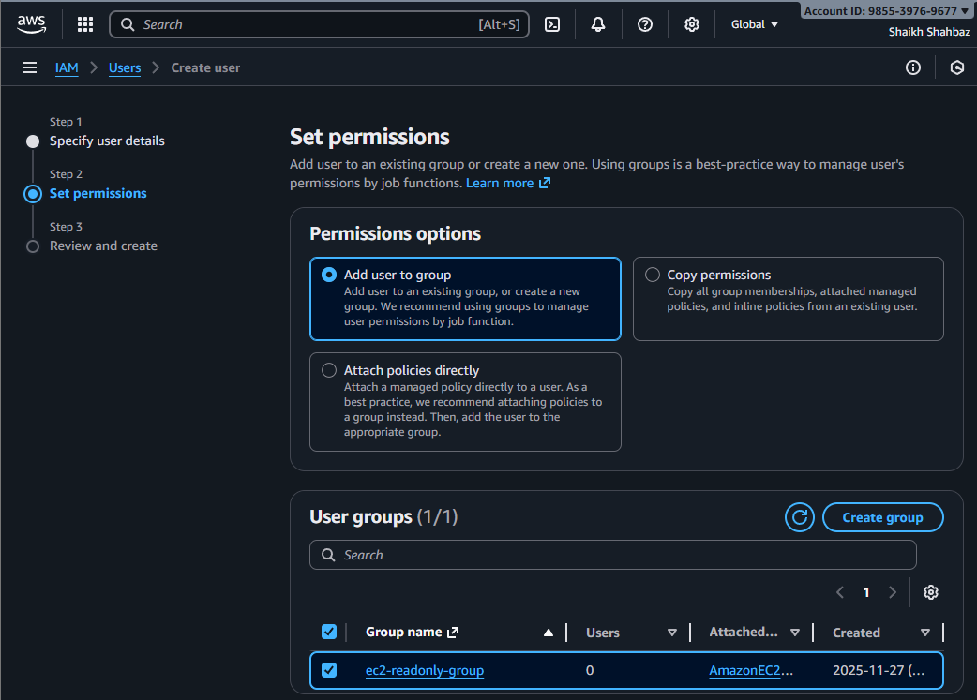
Create user
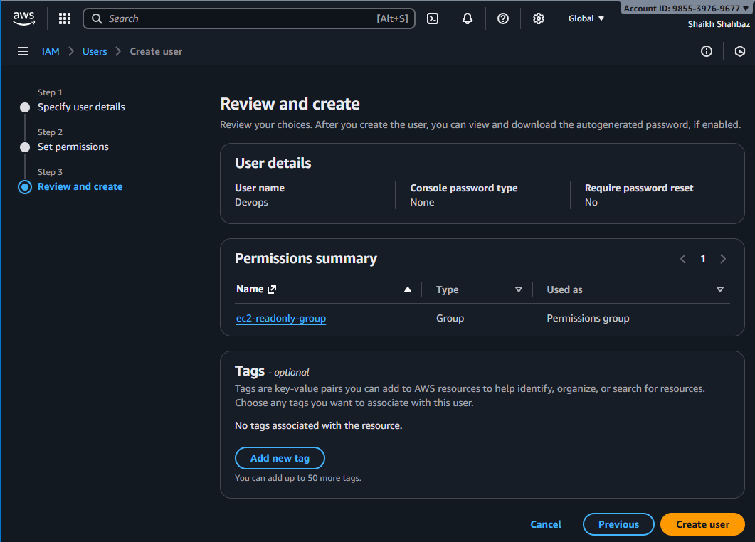
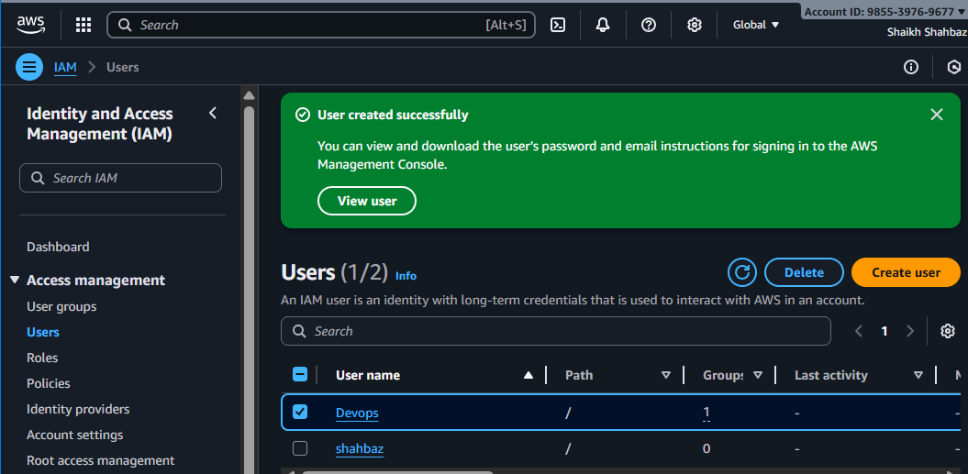
User Devops is created and added to the group previously created in task 2.

4. Write a bash script to create an IAM user with VPC full access.
Bash script to run in git bash
First we need to configure aws user account in bash cli
Goto your aws account security credentials create access key
aws –version
aws configure
provide access key :
provide secret key :
provide region : us-east-1
provide format : json
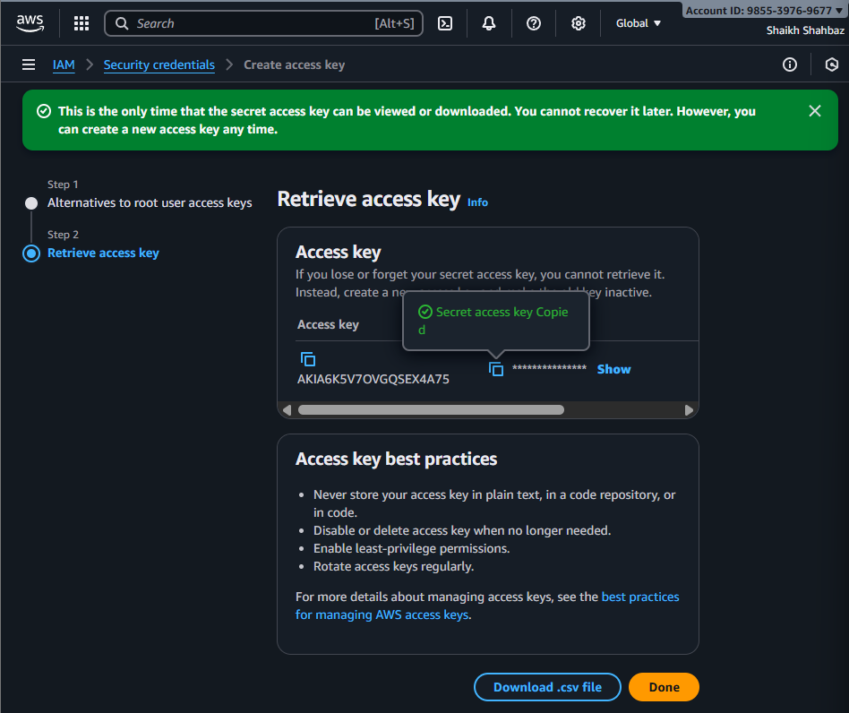
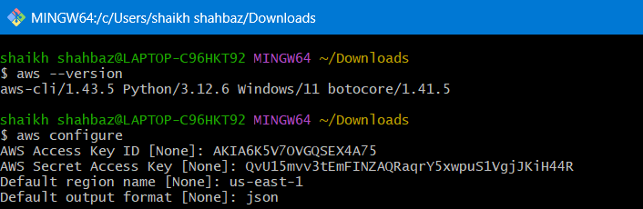
Script : create-vpc-user.sh
vi vpc-user.sh
chmod 755 vpc-user.sh
./vpc-user.sh
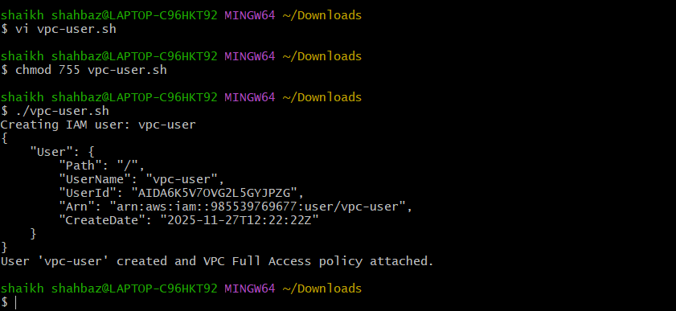
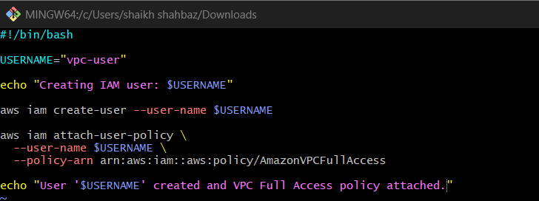
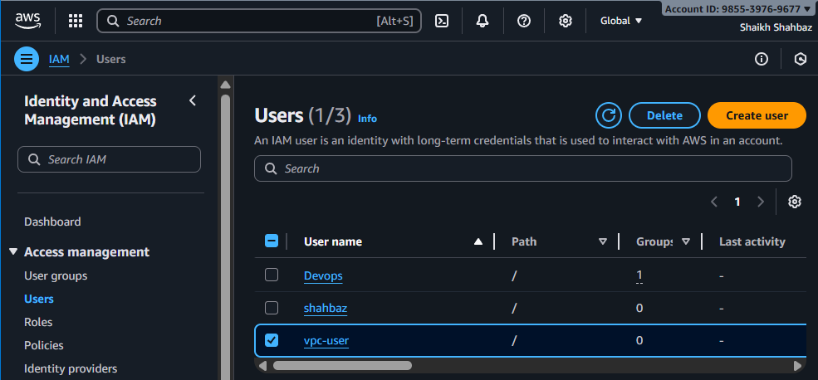
Vpc-user is created using aws cli

- Create an IAM policy to allow EC2 access for a specific user in specific regions only.
Go to IAM Policies Create Policy
Paste the JSON
Name : ec2-region-limited-policy
Attach the policy to the user/group
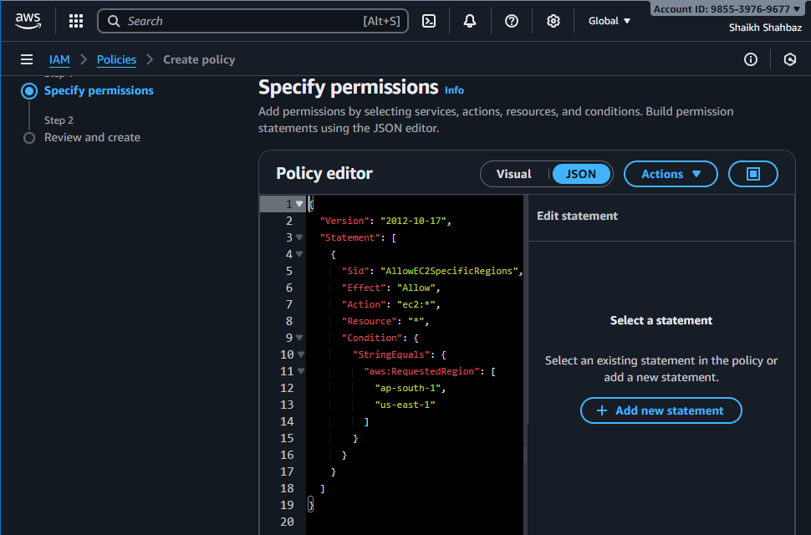
After that add name and description to the Policy

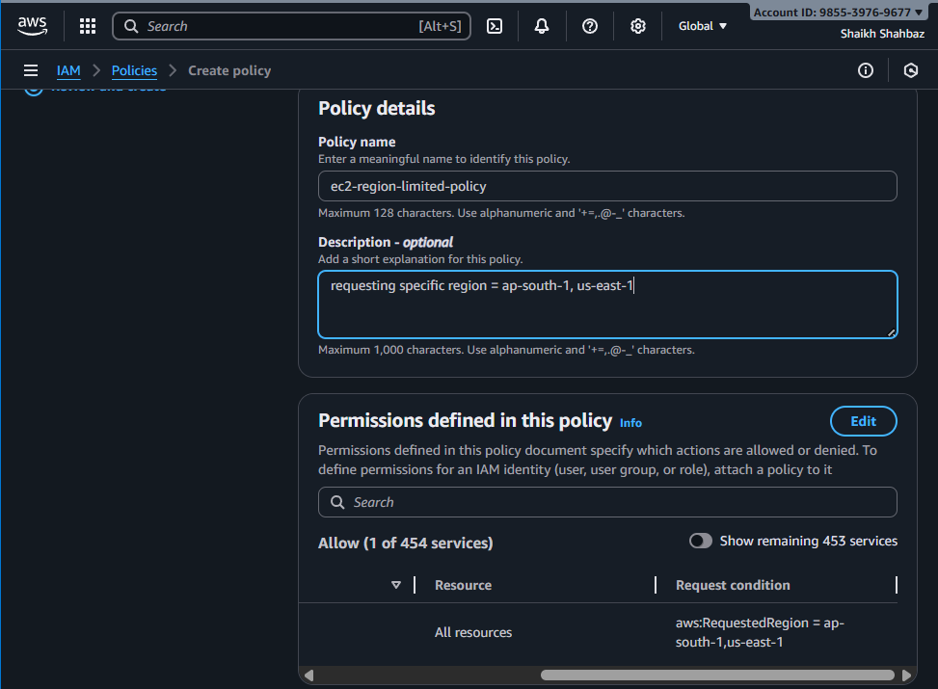
Go to the user and select the user u want in specific region
Then attach policy you created
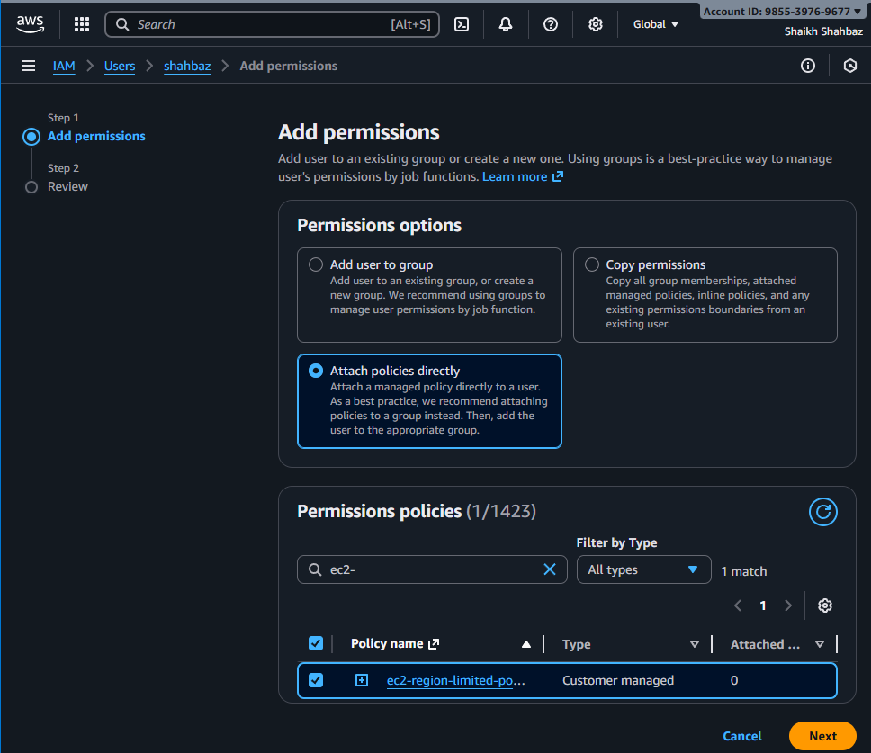
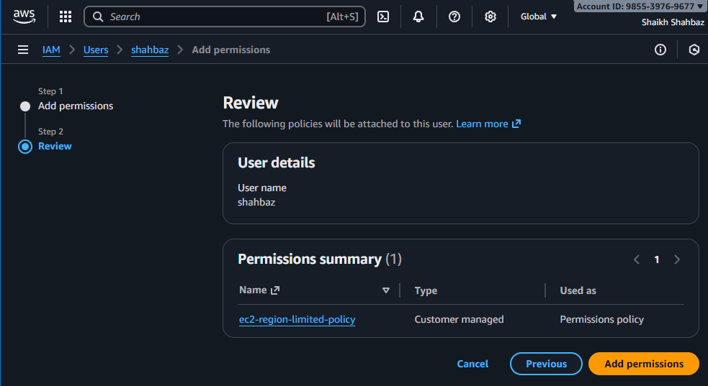
- We have two accounts: Account A and Account B. Account A user should access an S3 bucket in Account B.

Account A user Needs access to an s3 bucket in account B

Step 1: Identify both AWS Accounts
You need: Account A = My account Account B = Friends account
Account A (N.Virginia --- us-east-1)
IAM user: Devops
Account ID: AccountA-ID <my-id>
Account B (Bucket lives here)
S3 bucket name: my-bucket-b
Account ID: AccountB-ID <friends-id>

Step 2: Go to Account B → Open the S3 bucket
Log in to Account B
Go to S3
Select the bucket → example: my-bucket-b
Open Permissions tab
Edit Bucket Policy
This is where we will allow Account A.

Step 3: Add a Bucket Policy to Allow Account A User
Paste this JSON in Account B bucket policy
Replace <AccountA-ID> and <bucket-name> with real values

Now bucket side setup is done

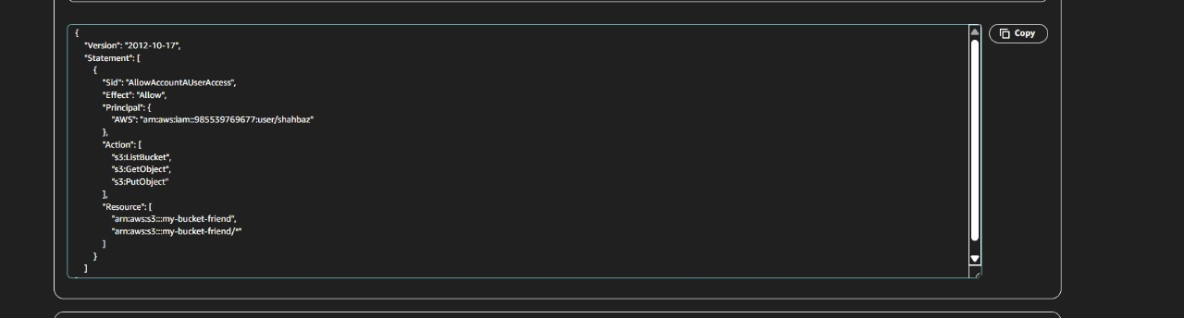

Step 4: Go to Account A (my-account)→ Give S3 Permission to the User
Now we configure the IAM user in Account A (friends).
Go to:
IAM → Users → Devops → Permissions → Add permissions → Create inline policy.
This is the user side permission.
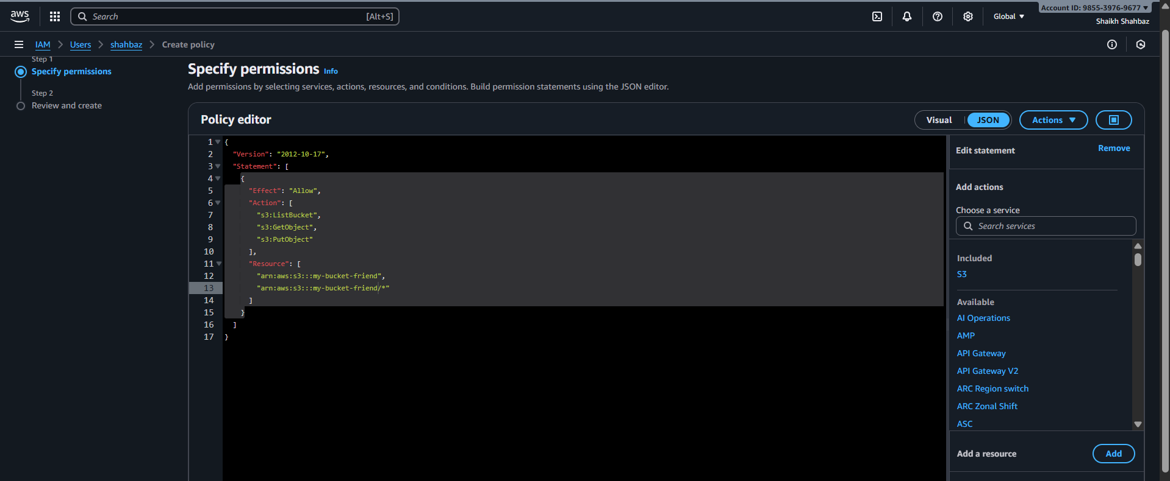
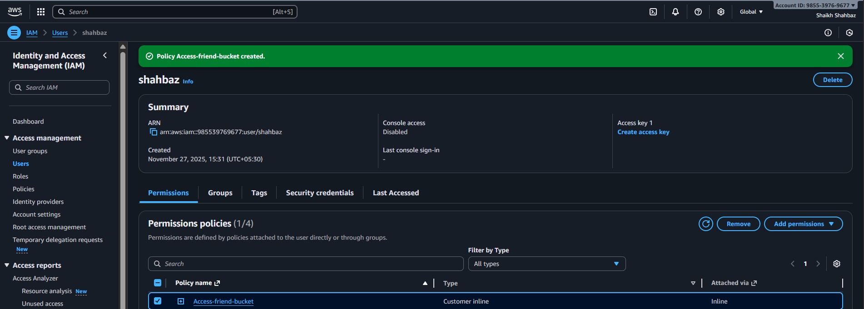

Step 5: Test From Account A User
aws –version
connect to your aws account through your aws account credentials:
aws configure

aws s3 ls s3://<bucket-name>
aws s3 ls s3://my-bucket-friend>
my-bucket-friend this s3 bucket is from my friend
and through my aws CLI, I can access to friends bucket
